Forecast the “Forecast Error” of the COMED Zone in PJM Market

Wendell Cathcart, Galen Hiltbrand, Yuliya Vachosovych, Sumin Wang

Duke University’s Nicholas School of the Environment

[1] ***Abstract*— The focus of this study was the forecast error of PJM, a U.S. regional transmission organization, in its electricity demand projections for the ComEd region. First, the team calculated PJM’s forecast error for 2011 through 2017. There was a decreasing trend in forecast error between 2015 to early 2016, and an increasing trend in forecast error since 2016. Next, the study analyzed correlations between forecast error and the weather, solar generation, wind energy generation, the economy, holidays and weekends. While some correlations between these variables and forecast errors had statistical significance, these correlations were weak and, consequently, they are not strongly correlated with forecast errors. Lastly, the study forecasted the forecast error for the first seven days of 2018. Of the forecasting models used, the seasonal ARIMA model was found to be the most accurate and indicated that PJM’s forecast error would remain consistent over the first week of January 2018. However, none of the forecast model correctly forecast the forecast errors in the first week of January 2018.**

**Even though the analysis did not find strong relationships between PJM’s forecast errors and the analyzed external variables, this study suggests that PJM should continue to seek methods to improve its forecast accuracy.**

*Keywords*—*forecast error, PJM, forecasting model, energy demand, peak load, grid reliability, ComEd*

# INTRODUCTION

Forecast errors in energy demand arise when utilities or system operators either overestimate or underestimate future electricity loads. Since the current energy system has a limited storage capacity, system operators must constantly balance energy supply to meet society’s demand. The benefits of an accurate load forecast include allowing an interconnected system to increase grid reliability and better plan their operations, energy mix, and finances[1].

   The study focused on the hourly forecast error of Pennsylvania New Jersey Maryland Interconnection LLC (PJM), a regional transmission organization (RTO) that services electricity to a large portion of the Eastern United States [2]. The study further narrowed in on one PJM zone, Commonwealth Edison (ComEd), which serves the greater Chicago area, because a smaller area is better for detecting variables specific to the area that may have influenced the forecast error.

## Objectives

Day-ahead hourly load forecasting is very important in the deregulated electricity market as it determines the dispatch scheduling of capacity, reliability of the whole system and the maintenance schedule for generators [3]. Divided into different timescales, PJM provides year-ahead, rolling 7-day, and day-ahead load forecasts. The focus of this study was on day-ahead load forecasts because a reduction of errors can significantly reduce operation costs and increase system reliability. Studying the forecast errors of the day-ahead hourly load forecasting can inform the accuracy of existing forecasting models and provide insights for improvement.

Additionally, research has shown that there are numerous factors that cause unanticipated shifts in electricity demand, thereby contributing to forecast error [1]. Investigating external factors that may have led to forecast errors can help system operators identify the variables to which they should give more attention. Thus, after calculating PJM’s ComEd forecast error, the correlations between forecast error and weather conditions, changes in the economy, peak load demands, days of the week, and annual holidays were explored.

The forecast error models provided valuable data regarding trends in PJM’s forecast error and the amount of forecast error they could expect moving forward. The final objective of this study was to use PJM’s ComEd 2017 forecast error to forecast PJM’s forecast error for January 2018 for the region.

## PJM Forecast Model

The PJM load forecast model is essentially an econometric regression model that produces estimates of load for each PJM zone. The major dependent variables included in the model are: calendar events, weather, economics, equipment and appliance saturation and efficiency. Starting from 2015, PJM also incorporated distributed solar generation into load forecast. PJM does not conduct the forecasting task solely; it contracted several companies to obtain data fed into the forecasting model. PJM contracted Itron to obtain residential and commercial equipment and appliance saturation and efficiency data. Moody's Analytics provides historical and forecast data for economic variables. PJM also utilizes historical weather data, load and peak load data and autoregressive error terms to improve forecast accuracy [4].

# METHODS

## Data Collection

To accomplish the objectives, the team acquired after-the-fact hourly electricity demand and load forecast for the ComEd region of the PJM transmission organization from 2011 to 2017. PJM provides hourly forecasts every six hours (5:45am, 11:45am, 17:45pm, 23:45pm) starting one day prior to the effective date and adjusts these forecasts during the effective date. For this study, the team chose PJM’s forecast evaluated for ComEd at 11:45pm the night before each effective date. Forecast values evaluated at 11:45pm is chosen because it’s closest to the operating day and it reflects the most updated forecast after PJM closes balancing market bid period [5].

Forecast errors are calculated by subtracting after-the-fact hourly electricity demand from forecasted demand (**Figure 1**). Positive errors represent over-forecast; negative errors represent under-forecast.

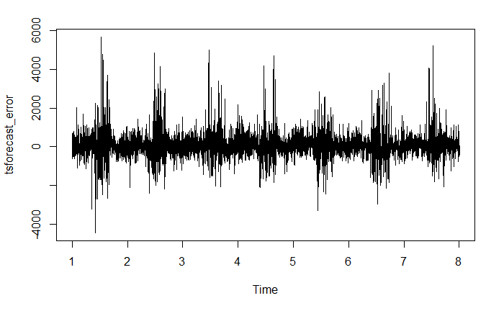

Figure. 1. Forecast Errors of PJM ComED zone from 2011 to 2017.

The team explored the presence of potential relationships between forecast error and the local weather, the economy, solar generation, wind generation, holidays, and days of the week.

To explore weather, the hourly weather data of a village, Shabbona, between January 1, 2016 and December 31, 2017 was acquired from the National Oceanic and Atmospheric Administration (NOAA) - Quality Controlled Datasets [6]. Shabbona was selected because the dataset only contains hourly temperature data from two weather stations (one in Shabbona, and another in Champaign) in Illinois, and Shabbona is closer to the city of Chicago.

Hourly solar generation was downloaded from PVWatts Calculator from National Renewable Energy Laboratory [7]. Parameters are set according to PJM’s Load Forecast Model Whitepaper [4] with DC-to-AC efficiency of 96%, tilt angle of 27 degree and 180-degree (south facing) azimuth.

Hourly wind generation data was provided on PJM website [8], which recorded total wind generation from the western territory of PJM.

To analyze the correlation with the economy, since it’s difficult to find economic indexes in hours or daily, the team acquired daily closing stock market prices for 2017 from the National Association of Securities Dealers Automated Quotations (NASDAQ) [9] as an instrumental variable for economic activities.

To analyze holidays, binary indexes indicating holidays and weekends were created for the 2017 calendar year.

All acquired data was imported and analyzed in R.

## Data Selection

PJM provides hourly forecast dating back to 2011, so the team did create a dataset for forecast errors from 2011 to 2017. However, because PJM re-examined its load forecast model in 2015 and implemented several revisions to its old model in December, 2015, the forecast errors before and after January 1, 2016 are the result of different factors. Therefore, to provide a more accurate forecast for forecast errors in 2018 and constrained by the number of data points some of our models can handle, only a subset of the acquired data (from January 1, 2017 to December 31, 2017) was used to fit different time series models. **Figure 2** shows that there is a decreasing trend for forecast errors from 2015 (x=5) to 2016 (x=6) and an increasing trend since 2016, which reflects the effect of revised forecast model on forecast accuracy.

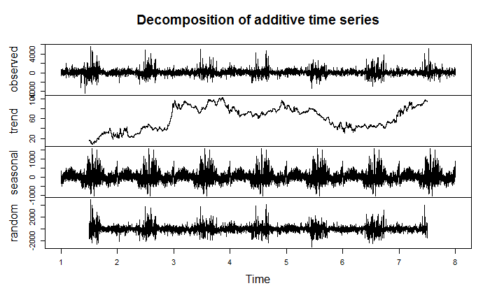

Figure. 2. The decomposition of 2011-2017 forecast errors.

## Data Analysis

The following R packages were used during the analysis: “data.table,” “tidyr,” “dplyr,” “forecast,” “Kendall,” “stats,” “tseries,” “smooth,” “matrixStats,” “outliers.” The error values were then formatted into a time series using the *msts()* function. Unlike the *ts()* function, the *msts()* function has more flexibility to account for multiple seasonalities in a time series [10]. Given that the forecast data is hourly, the *msts()* function incorporates daily, weekly, and yearly seasonality (seasonal periods=c(7, 168, 8760)). The auto-correlation function (*Acf()*) and the partial auto-correlation function (*Pacf()*) were applied to the error data to determine whether forecast errors were  independent of each other.

The *decompose()* R function is used to separate the seasonal, trend, and irregular components. The decomposed seasonal trend revealed the presence of high errors during summer time for all 7 years (**Figure 2**).

Stationarity is important in time series because many statistical methods in time series analysis and forecasting assume stationarity. To check the stationarity of the time series, the Mann-Kendall test, Augmented Dicker Fuller (ADF) test and the Kwiatkowski–Phillips–Schmidt–Shin (KPSS) test were used on the deseasonalized time series.

Correlation (*cor()*) tests helped identify the factors, such as temperature, solar generation, and stock prices that could influence the error time series. Data for stock prices was available only as daily values, which meant errors had to be converted from hourly to daily values to run appropriate correlation tests. The sum of absolute hourly values for each day was calculated to acquire daily error values.

In addition to examining the factors that influence hourly and daily error values, the team also examined factors that could have influenced peak error values for 2017. The team examined whether the day of the week and the presence of a holiday would coincide with higher absolute forecast errors for those days. The team wondered whether weekends or weekdays corresponded with trends in forecast error, suggesting that differing load patterns might affect forecast error. Similarly, the team also tested whether holidays and special occasions in the ComEd region corresponded with higher forecast error as a result of the divergence from normal power consumption. All ten Federal holidays [11] as well as days that are special to the Chicago area were included in the analysis: Pulaski Day, Lollapalooza, Jazz Fest, and Opening Day (MLB). Both the day of the week and holidays were compared to daily forecast error totals. Following the correlation tests, the team used 2017 error data to forecast the hourly errors for the first seven days of the January 2018. Five forecasting models were run: naive (*auto.arima(y, max.D=0, max.P=0, max.Q=0)*), seasonal (*auto.arima()*), state-space model (*StructTS()*), exponential smooth (*es()*), moving average (*sma()*). These forecast models were then checked for accuracy using the *accuracy()* function. The *accuracy()* function compared the model forecast errors to the 2018 PJM forecast errors.

# RESULTS

## ACF and PACF

The ACF and PACF plots (**Figure 3 and Figure 4**) confirmed that the error data was not a white-noise series, meaning that some correlation between values and their times does exist.

Significant autocorrelations were found in the residuals beyond 48 hours (equivalent to 2 days), which refuted PJM’s conclusion in its 2016 Load Forecasting Model White Paper that “there was no longer autocorrelation in the residuals” and “the issue had been adequately resolved” [4].

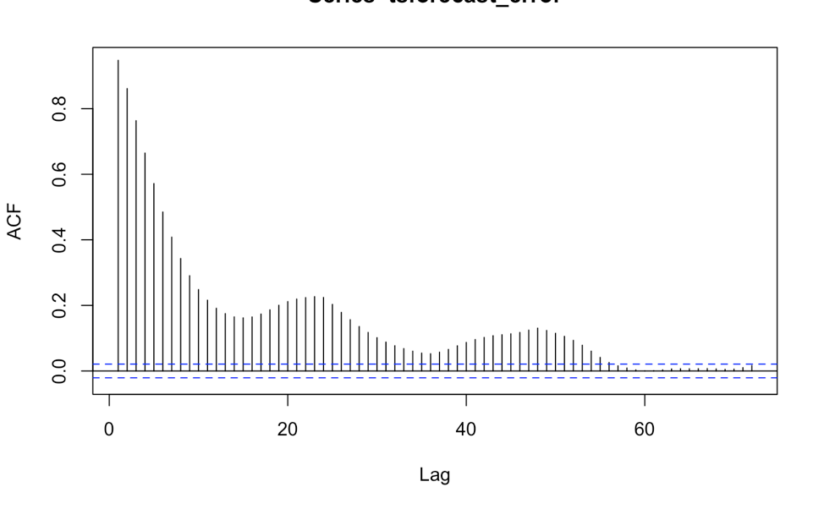

Figure 3. ACF of the forecast errors from January 1, 2017 to January 3, 2017. Each lag is an hour. Any lag with ACF value above the blue dashed line is significant. Seasonality is observed.

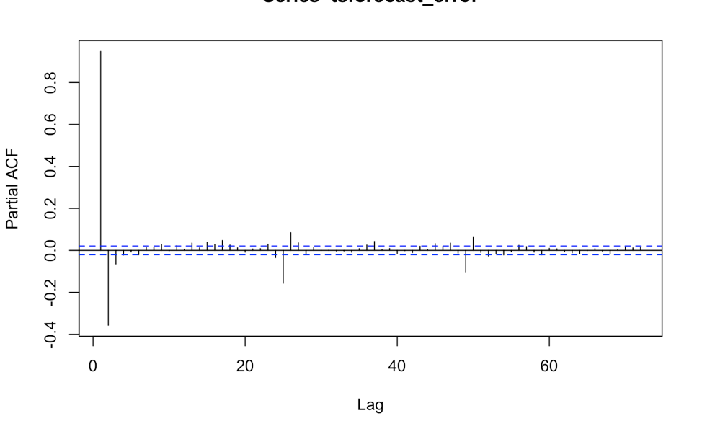

Figure 4. PACF of the forecast errors from January 1, 2017 to January 3, 2017. Any lag with PACF value above the blue dashed line is significant.

Because the ACF plot shows a slow decay and PACF has a clear cut off at lag 2, this is an autoregressive process.

## Stationarity

For the reasons outlined in the *Data Selection* subsection, stationarity tests were run on a subset of data: 2017.

The Mann-Kendall test was also conducted on deseasonalized 2017 forecast errors. The p-value is 0.44, which means that the forecast errors in 2017 is stationary. The p-value of the ADF test on was 0.01, indicating stationarity. The p-value of KPSS test for level stationarity is equal to 0.1. Accepting the null hypothesis verifies that the deseasonalized 2017 forecast error time series is stationary.

However, it is worth noting that the Mann-Kendall test on deseasonalized 2016-2017 forecast errors provided the following results: tau = 0.0304 and 2-sided p-value =< 2.22e-16. These results indicated that there is a monotonic but very weak trend in the forecast errors between January, 2016 and December, 2017. If further research uses data from 2016-2017 to conduct forecasting, the monotonic trend needs to be removed before forecasting.

## Temperature

The team expected to see a high correlation between temperature and forecast errors because higher temperature might have led to a greater consumption of electricity.

Originally, the team only conducted the correlation test between 2017 forecast errors and temperature. The relationship is significantly different from zero but weak. Later, the team incorporated forecast errors and temperature data back to 2011. However, the analysis still did not result in a strong correlation even after comparing absolute forecast errors and absolute percent forecast error ($\frac{Hourly Forecast-Hourly Load}{Hourly Forecast}*100\%$) to temperature. All of the correlation tests (Pearson, Kendall and Spearman) generated small p-values (<0.05), but none of them show that the correlation is strong enough. The correlations between forecast errors and Heating Degree Days (HDD) and Cooling Degree Days (CDD) were also tested but the tests still produced low correlation coefficients.

## Solar Generation

Limited by one-year data, the team only tested the correlation of solar generation with the 2017 forecast errors. The resulting p-value of 0.65 demonstrated that there was no correlation between solar generation and forecast errors. This result demonstrated that PJM’s forecast model successfully eliminated the impact of solar generation from residential PVs on forecast errors.

However, the result does not mean that solar generation has little impact on PJM operations. During the Solar Eclipse on August 21, 2017, PJM recorded a net decrease of 5,000 MW throughout the eclipse. And PJM plans to integrate the Aug. 21 event to forecast electricity demand in the next solar eclipse expected to occur in 2024 [12].

## Wind Generation

2017 wind generation was tested with 2017 forecast errors. While the p-value was small, the correlation coefficient (-0.11) did not indicate a strong correlation.

## Economy

The relationship between the economy and forecast errors was examined by running a linear regression between NASDAQ stock prices and forecast errors for 2017. The results indicated that there is no linear relationship between the two factors because the p-value was equal to 0.44, which is greater than the 0.05 level of significance.

## Calendar Events

The team also examined absolute maximum forecast errors for the ComEd region for 2017 (**Figure 5**). On 40 of the 365 days, the highest error for the day occured at 8pm. The next most frequent maximum errors occurred at 6pm (32 days), 9pm (29 days), and 7pm (29 days). There were also frequent maximum errors at 12am (30 days) and 1am (26 days). Most of the hours at which maximum errors occur aligned with the hours of maximum electricity demand. Maximum demand occurred most frequently at 7pm (91 days), 8pm (58 days), and 6pm (49 hours).

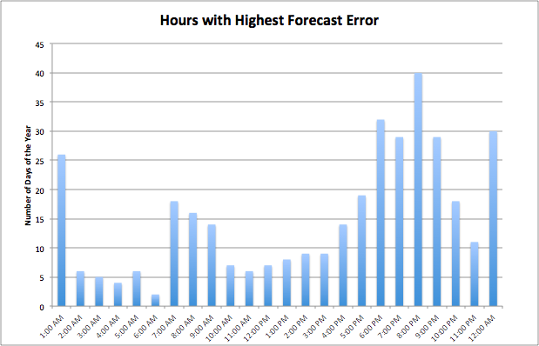

Figure 5. Hour of the day at which the highest error occurs during 2017.

The team expected that days on which peak load hours differed from the peak forecast error hours would coincide with additional forecast error because ComEd’s model may have failed to account for some other factor driving load. The team, therefore, compared holidays to peak errors by creating a binary time series representing days on which the peak forecast hour did not match the true peak load hour which we compared against the 2017 forecast time series. A statistically significant but weak positive correlation between “Peak Mismatch” and daily forecast error was found. The team found the significance of this correlation by creating a linear regression between the two series and the team used the Pearson correlation test to find the two series have a weak, positive correlation coefficient (p-value: 0.0001, corr: 0.2068).

Similarly, the team ran a linear regression between a binary series where 1’s represent weekends and 0’s represent weekdays and the daily forecast error. The results were not statistically significant and the correlation was weak and negative (p-value: 0.0540, corr: -0.1010).  The presence of a holiday (or special day in Chicago) appeared to have a statistically significant, weak, and positive correlation with forecast error (p-value: 0.0029, corr: 0.1554).

# FORECAST FORECAST ERRORS

Forecast errors were forecasted using several time series forecast models: naive, seasonal ARIMA, exponential smooth, moving average, and state space models. The result is shown as following:

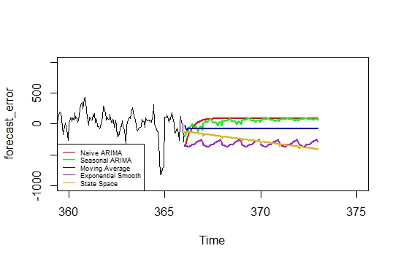

Figure 6. Hourly forecasts for the first seven days of 2018.

Naïve forecast uses a single previous value of a time series as the basis for forecasting. It is a simple and quick way to forecast but it cannot provide high accuracy. Similarly, moving Average averages a number of most recent values in generating forecast. The more data points included, the less responsive the model will be. That is why the forecast results completed by these two methods turn into a flat line because they are based on the average value of previous data. They are not effective in forecasting forecast errors.

Seasonal ARIMA is ARIMA model that can be applied directly on forecasting seasonal data. The disadvantage of seasonal ARIMA is that it can only do short-term forecasting. As the time horizon increases, the forecast will converge to the mean, which explains the trend with decreasing variance in **Figure 6**.

Exponential smoothing is based on previous forecast plus a percentage of forecast error. State space model can update the equations based on observing the real value of a forecast data. Both of them involves a learning process.

In this analysis, with the exception of the state-space model, the models predicted the forecast error would remain consistent over the next 7 days (**Figure 6**).

Methods taken is basically an out-of-sample forecast by using observations from 2018 to evaluate the model performance. Accuracy checks indicated that the seasonal ARIMA model was the most accurate because it possessed the lowest errors (**Table 1**).

TABLE 1

ACCURACY CHECK RESULTS

|  |  |  |  |  |
| --- | --- | --- | --- | --- |
| **Forecasting Model** | **ME (Mean Error)** | **RMSE (Root Mean Squared Error)** | **MAE (Mean Absolute Error)** | **MAPE**  **(Mean Absolute Percentage Error)** |
| **Naive** | 169.4310 | 164.4310 | 164.4310 | 90.0783% |
| **Seasonal** | -5.8368 | 5.8368 | 5.8368 | 3.1031% |
| **Exponential Smooth** | 150.9473 | 150.9473 | 150.9473 | 80.2514% |
| **Moving Average** | -158.293 | 158.293 | 158.293 | 84.157% |
| **State Space** | -34.8556 | 34.8556 | 34.8556 | 18.5311% |

However, after plotting the forecast results with actual forecast errors in 2018 (**Figure 7**), the reality is that none of the model works well on forecasting forecast errors. The true mechanism driving changes in forecast errors might be more complicated than it is expected.

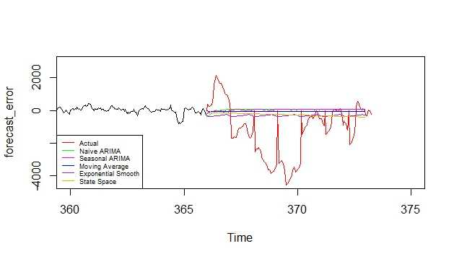

Figure 7. Comparison between actual forecast errors in 2018 with hourly forecasts for the first seven days of 2018.

# DISCUSSIONS AND LIMITATIONS

When 2017 data was used to run correlation tests with temperature, solar radiation, wind generation, and stocks, no strong relationships between errors and the other factors were found. The team, therefore, decided to incorporate more years into the time series analysis to see if additional data would reveal a correlation. After running a correlation test between error values for 2011-2017 and temperature for the respective years, the team found there was still no strong correlation.

There are several potential reasons why the tested factors did not strongly correlate with forecast errors:

**Renewable generation**: first, renewable capacity is comprised of 8% of PJM total capacity [13]. Second, the wind generation data is for the whole western territory of PJM, so it is also highly influenced with factors outside of ComED.

**Temperature**: temperature is already considered by PJM forecast model. And the hourly temperature data used is limited to a village, not representative of the whole ComED region. Also, forecast errors might not be correlated with actual temperature but with the accuracy of temperature forecast. The limitation the team encountered is to find the forecast errors of temperature due to the limited availability data on temperature forecasts.

**Economy:** Stock price from NASDAQ is not an ideal index to evaluate economic activities since it does not reflect local economic activity and it is largely affected by other factors. Other instruments and indexes are needed to study the relationship between forecast errors and economy.

**Correlation test**: The relationship between factors considered and forecast errors might be very complex and not captured by the correlation tests the team used for this study.

None of the factors examined have shown to significantly influence the forecast accuracy. However, some of the factors (such as temperature and wind generation) did show significant but weak correlation with forecast errors. This could suggest that investigating the real driver of forecast errors requires more complex statistical analysis and the consideration of more factors. Further research can also use other methods such as ARMAX or Dynamic Regression to allow for inclusion of other predictors.

Additionally, the lack of strong correlation with other factors, such as day of the week and holidays, may suggest that PJM's forecasting model may already account for these factors. Yet despite potentially accounting for these factors, the PJM model continues to exhibit high forecast errors. In fact, the decomposed time series show an increasing trend in forecast errors from 2016 to 2017 (Figure 1). This signals a deterioration in performance and the team, therefore, recommends that PJM reevaluates its forecast model.

Forecast Errors might not be the best tool to evaluate the performance of forecasting models used in electricity market. It is expected that when baseline electricity demand is high, the magnitude of over-forecast or under-forecast will also be higher. Since reserve is scheduled as percentage of total generation, it is worth studying forecast error percentage. If the model performs well, forecast error percentage can remain relatively constant throughout the year even though the magnitude of underlying forecasted electricity demand varies greatly.

# CONCLUSIONS

Investigating the forecast errors of PJM electricity demand forecasts unveils that even though PJM made an effort in improving its forecast models in 2015, the model still has many issues. The team recommends PJM to constantly re-examine its model, especially after observing the increasing trend in 2017 forecast errors. In days when forecast errors can be as high as 4,000 MW, the system is exposed to a high level of uncertainty and the overall cost is also very high.

No strong correlations are found between forecast errors, temperature, wind generation, solar generation and calendar events. However, the relationships are statistically different from zero which suggests that further research is needed to untangle their relationships.

Among all the time series models used for forecasting, seasonal ARIMA generates a result with lowest error. However, the forecasted values for 2018 are very different from actual forecast errors. Therefore, other methods should be explored to accurately forecast forecast errors.

# Acknowledgment

The team acknowledged Professor Luana Lima for providing guidance throughout this project.

References and Footnotes

[1] Tao Hong, Mohammad Shahidehpour, *Load Forecasting Case Study*, Eastern Interconnection States’ Planning Council (EISPC) & National Association of Regulatory Utility Commissioners (NARUC), 2015. <https://pubs.naruc.org/pub.cfm?id=536E10A7-2354-D714-5191-A8AAFE45D626>

[2] *Who We Are,* About PJM, PJM Interconnection. USA[Online]. Available: <http://www.pjm.com/about-pjm/who-we-are.aspx>   
Accessed on: April. 27, 2018.

[3] Kishan Sahay, M.M. Tripathi, “Day ahead hourly load forecast of PJM electricity market and iso new england market by using artificial neural network”, Innovative Smart Grid Technologies Conference (ISGT), 2014 IEEE PES.

[4] *Load Forecasting Model Whitepaper,* Resource Adequacy Planning Department (RAPD), PJM Interconnection. USA. 2016.

[5] *PJM Manual 11: Energy & Ancillary Services Market Operations*, Day-Ahead and Real-Time Market Operations, PJM Interconnection. USA [Online]. April. 12, 2018.

[6] *Quality Controlled Datasets*, National Centers for Environmental Information, National Oceanic and Atmospheric Administration (NOAA). Available: <https://www.ncdc.noaa.gov/crn/qcdatasets.html>, Accessed on: March. 30, 2018.

[7] *PVWatts Calculator*, NREL, U.S. Department of Energy. Available: <https://www.nrel.gov/about/mission-programs.html>, Accessed on: April. 28, 2018.

[8] *Wind Generation*, System Operations, PJM Interconnection. USA [Online]. Available: <http://www.pjm.com/markets-and-operations/ops-analysis.aspx>, Accessed on: April. 1, 2018.

[9] *Historical Prices*. NASDAQ. USA [Online]. Available: <https://www.nasdaq.com/symbol/nasdaq/historical>, Accessed on: April 12, 2018.

[10] *Public Holidays in Illinois in 2017*, Office Holidays, 2017. <https://www.officeholidays.com/countries/usa/regional.php?list_year=2017&list_region=Illinois>

[11] Philip G. Gould, Anne B. Koehler and et al., “Forecasting Time Series with Multiple Seasonal Patterns,” *European Journal of Operational Research*, Vol. 191, no. 1, pp. 207-222, Nov. 2008, [10.1016/j.ejor.2007.08.024](https://doi.org/10.1016/j.ejor.2007.08.024).

[12] “PJM Sees Impact on Solar Generation during August Eclipse.” PJM Inside Lines. August. 22, 2017. Available: <http://insidelines.pjm.com/pjm-sees-impact-on-solar-generation-during-august-eclipse/>, Assessed on: April 10, 2018.

[13] *Generation Fuel Mix*, Markets and Operations, PJM Interconnection. USA [Online]. Available:  <http://www.pjm.com/markets-and-operations.aspx>, Accessed on: April. 16, 2018

1.